WV Side of AE design questions/answers for Business Team:

1. The accessibility survey (mock-up shown below), will this show all questions/answers, or just those that require an action of change?
   1. If just those that require an action of change, when you make a change to a response after discussion with the clerk and the response is now not requiring an action of change, do we expect that question to fall off the list?
   2. If showing all questions/answers, when a response is updated by you, I assume we also expect the findings to then update within the table as well when saving the new response?

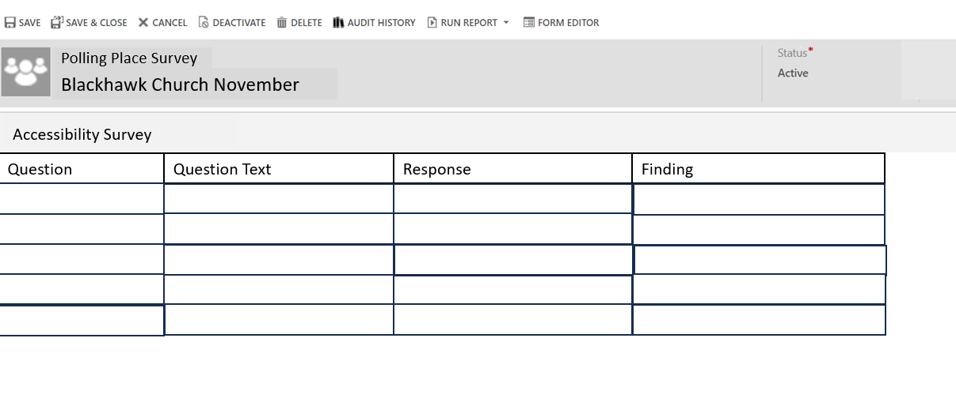

1. For editing responses in the accessibility survey, we discussed the idea of clicking on the question number (first column above) and this would be a link to the screen where you can edit the responses as needed after discussions with clerks. Are we expecting only that question and the associated response options to appear on the new screen? Or would it be to all questions and response options so you could update them all as needed for that polling place?
2. The associated views screen of the polling place surveys within a polling place record (mock-up shown below), other than the default view of all surveys associated to that specific polling place are there any other views we think we would need here? I think we will want other views under a specific election, but not within a single polling place one, correct?

1. On to the associated view screen of the polling place surveys within a specific election (mock-up shown below), I think we want the default view to be the record(s) specific to the municipality under which the user is set to. And it would show all polling places within that municipality which had a survey done for that election. But I was thinking do we also want to do other views here? Maybe one of all polling place surveys within the county associated to the municipality the user has chosen within that particular election. And another with all polling place surveys within the state for that particular election. Or are we strongly against all users not being able to see the surveys from other munis not their own? If we do them as separate views, technically anyone could choose those other views and see them, although a lot of users don’t know other views are an option.

I’ll share some mock-ups (ignore the survey naming convention as this was created prior to our meeting last week).

